**Carlos Donoso Cabero**

ejercicios sql

Máster Data Analytics para la Empresa - EDEM

1. Proporciona una SQL que muestre los siguientes datos:

* -  Nombre Actor
* -  Apellido Actor

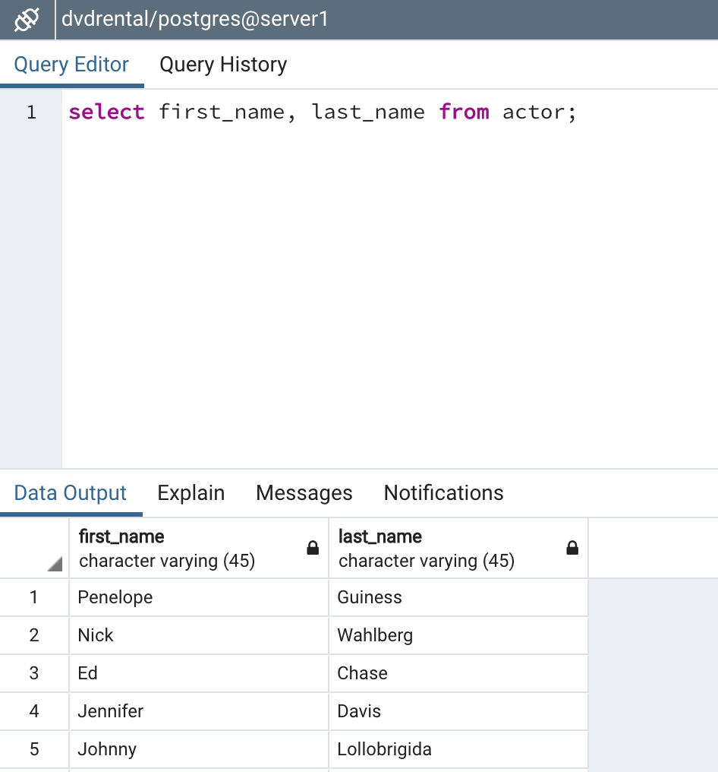

select first_name, last_name from actor;

1. Proporciona una SQL que muestre los siguientes datos:

* -  Nombre Actor
* -  Título de la Película

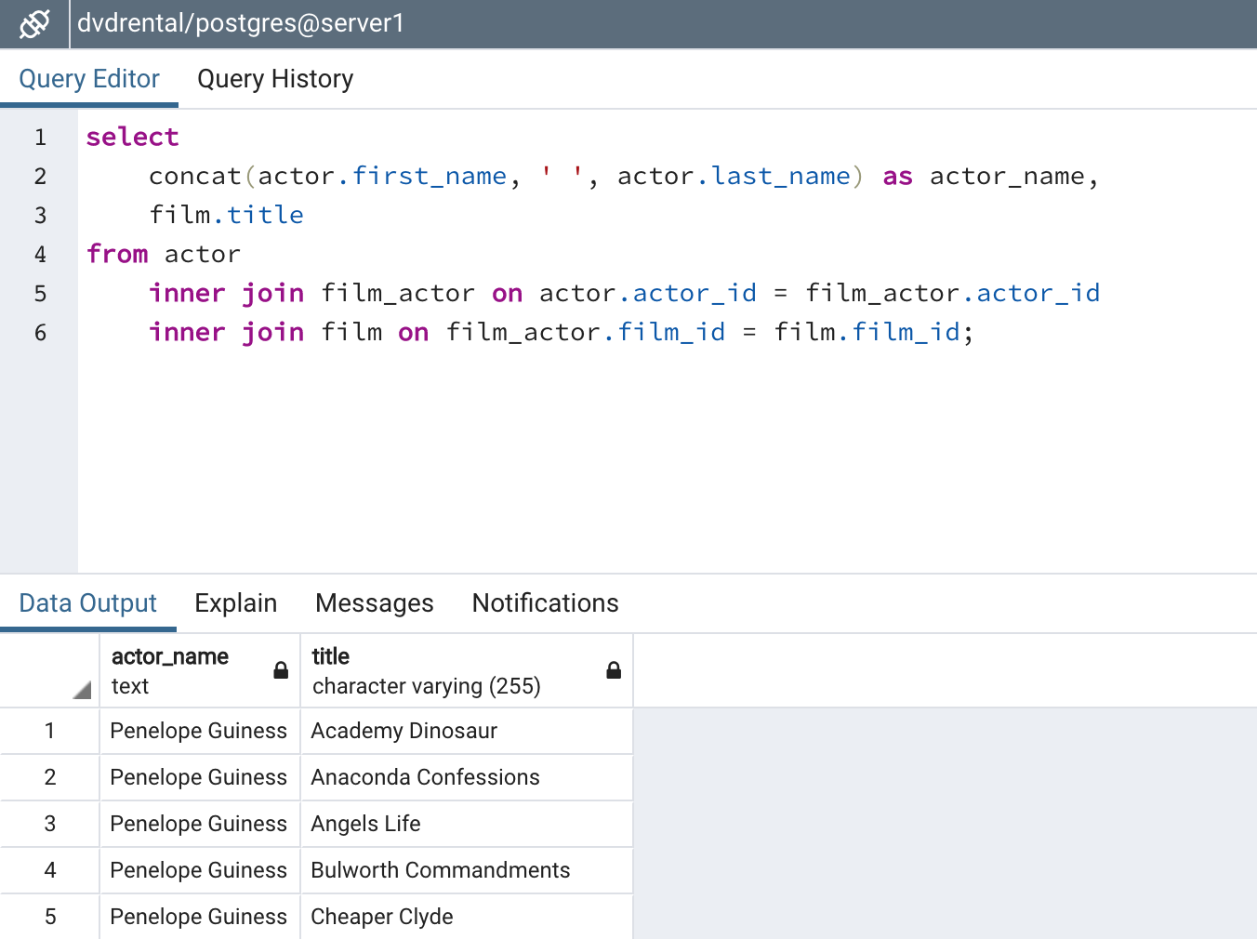

select

concat(actor.first_name, ' ', actor.last_name) as actor_name,

film.title

from actor

inner join film_actor on actor.actor_id = film_actor.actor_id

inner join film on film_actor.film_id = film.film_id;

1. Proporciona una SQL que muestre los siguientes datos:

* -  Nombre Actor
* -  Número de películas
* -  Ordenar de mayor a menor

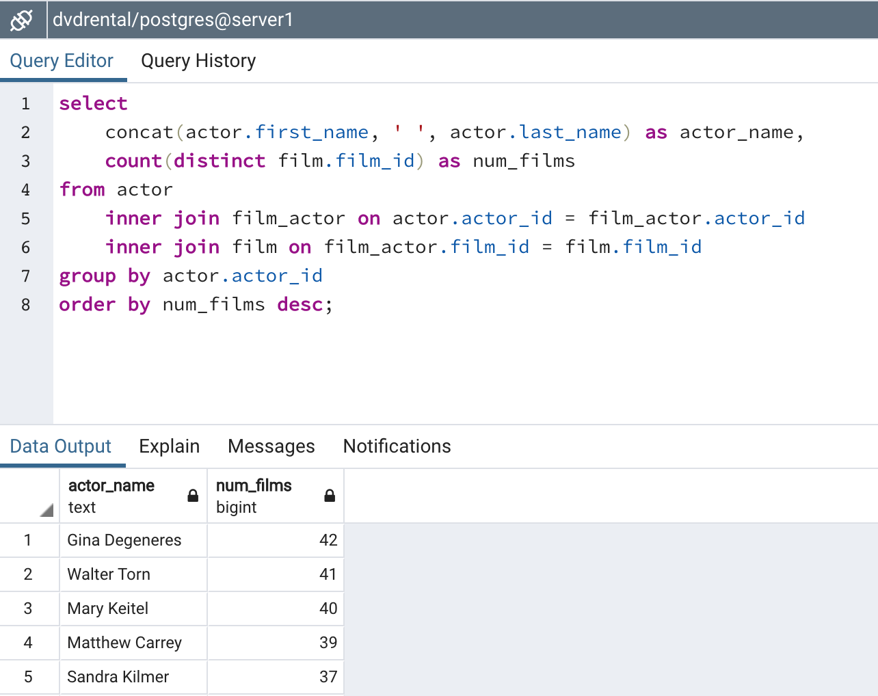

select

concat(actor.first_name, ' ', actor.last_name) as actor_name,

count(distinct film.film_id) as num_films

from actor

inner join film_actor on actor.actor_id = film_actor.actor_id

inner join film on film_actor.film_id = film.film_id

group by actor.actor_id

order by num_films desc;

1. Proporciona una SQL que muestre los siguientes datos:

* -  Película
* -  Número de veces alquilada

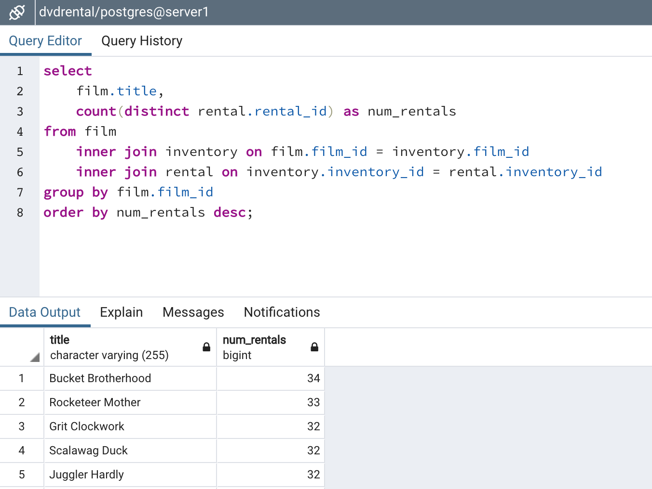

select

film.title,

count(distinct rental.rental_id) as num_rentals

from film

inner join inventory on film.film_id = inventory.film_id

inner join rental on inventory.inventory_id = rental.inventory_id

group by film.film_id

order by num_rentals desc;

1. Proporciona una SQL que muestre los siguientes datos:

* -  Película
* -  Dinero recaudado por película

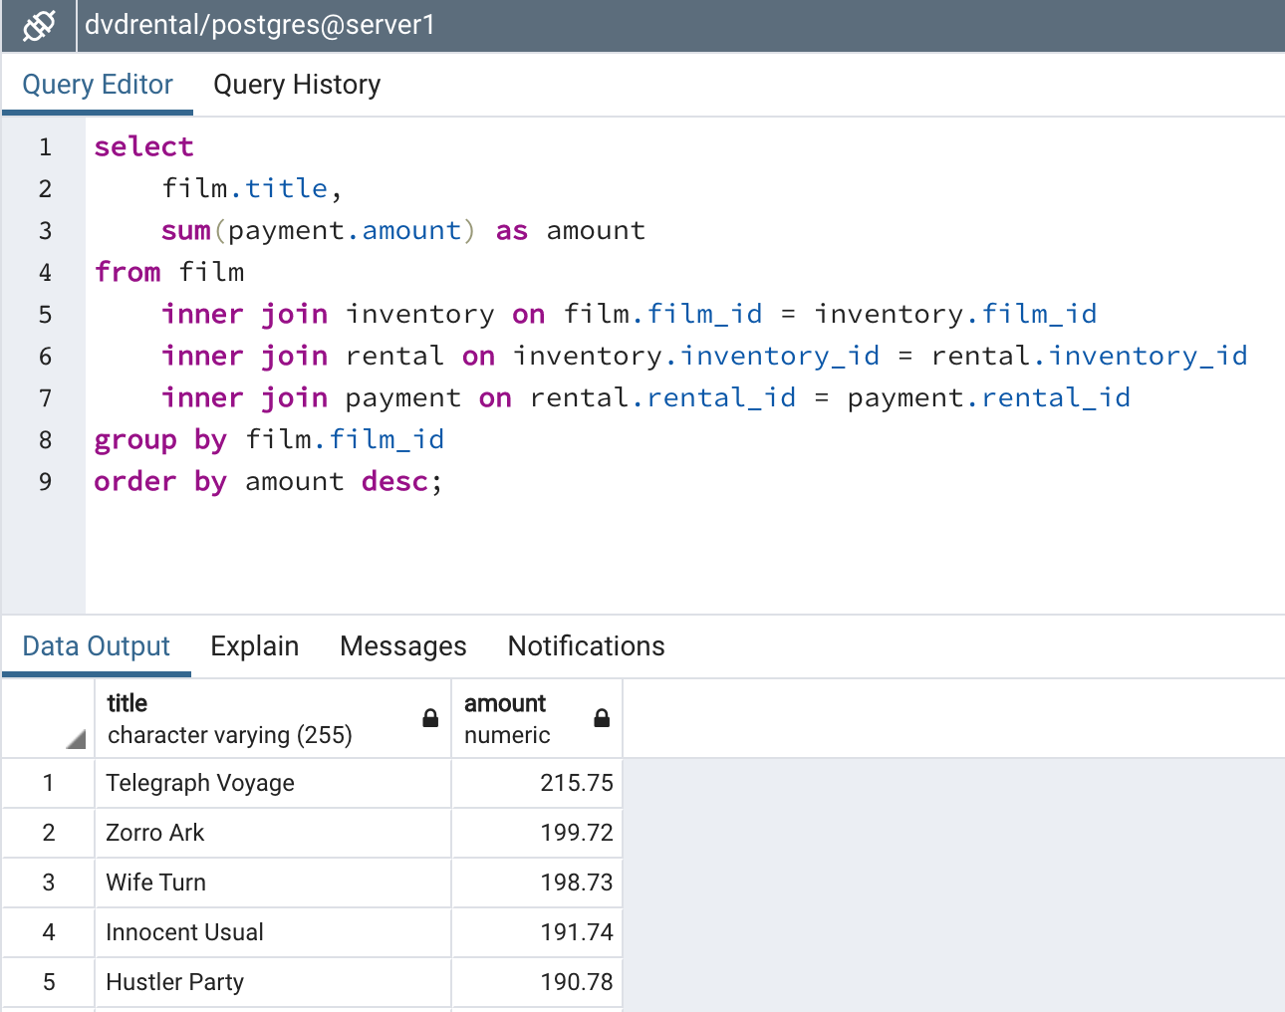

select

film.title,

sum(payment.amount) as amount

from film

inner join inventory on film.film_id = inventory.film_id

inner join rental on inventory.inventory_id = rental.inventory_id

inner join payment on rental.rental_id = payment.rental_id

group by film.film_id

order by amount desc;

1. Proporciona una SQL que muestre los siguientes datos:

- Nombre del mejor cliente (mayor gasto)

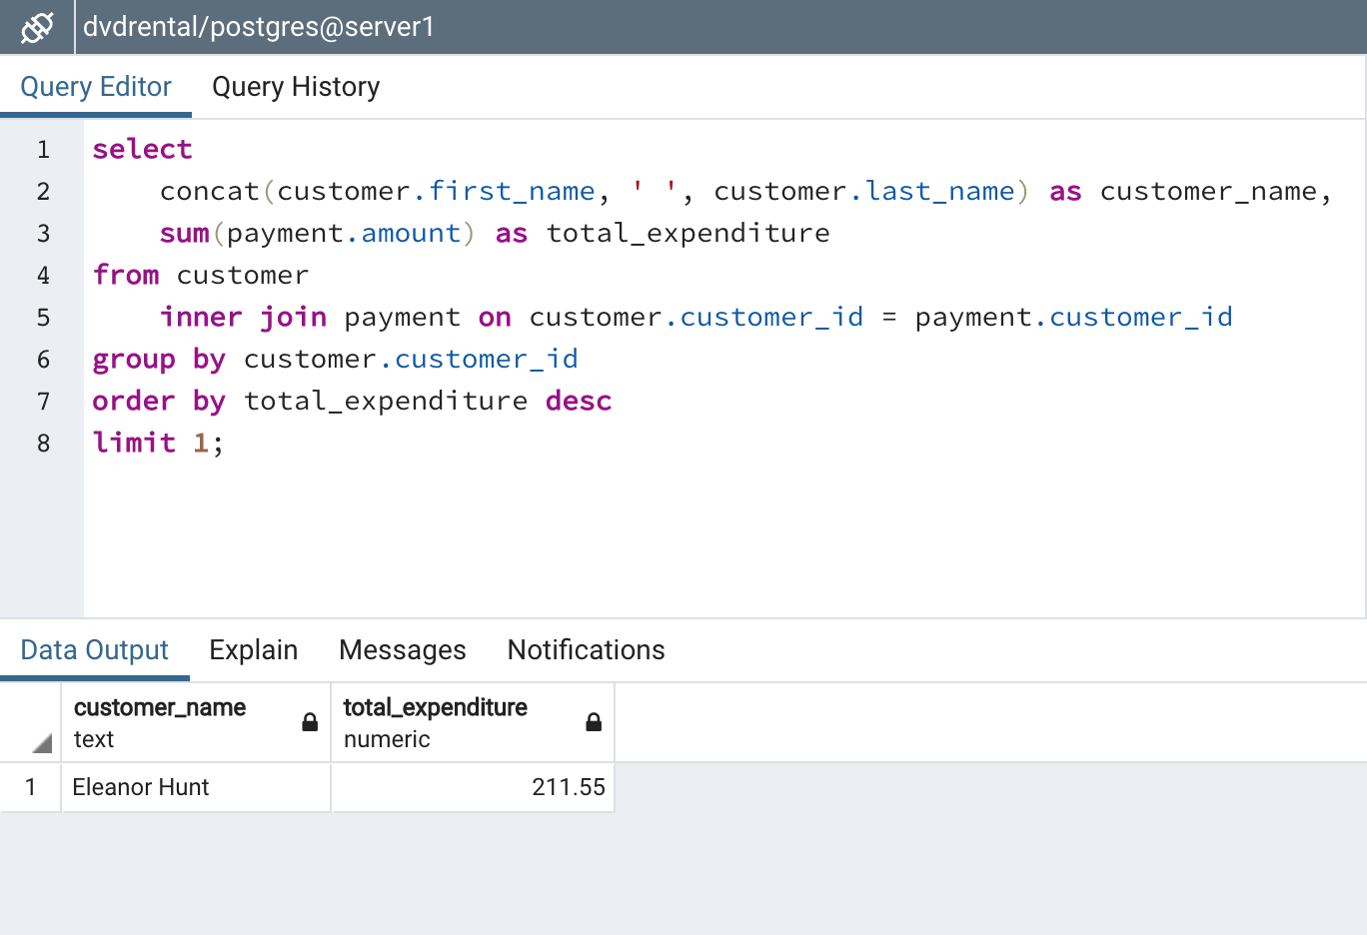

select

concat(customer.first_name, ' ', customer.last_name) as customer_name,

sum(payment.amount) as total_expenditure

from customer

inner join payment on customer.customer_id = payment.customer_id

group by customer.customer_id

order by total_expenditure desc

limit 1;

1. Proporciona una SQL que muestre los siguientes datos:

- Nombre del mejor cliente (mayor número alquileres)

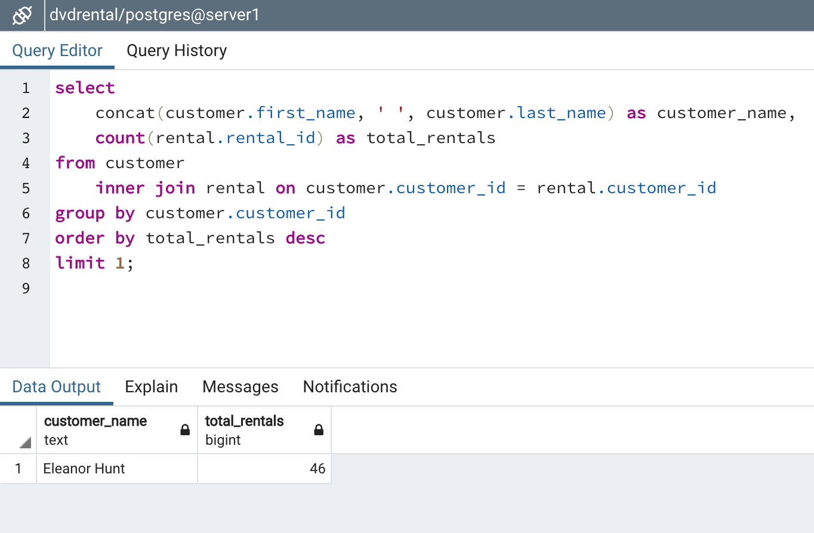

select

concat(customer.first_name, ' ', customer.last_name) as customer_name,

count(rental.rental_id) as total_rentals

from customer

inner join rental on customer.customer_id = rental.customer_id

group by customer.customer_id

order by total_rentals desc

limit 1;